**User documentation**

**General description:**

This Python trivia game challenges players' knowledge of Python through a series of questions. Each question has four possible answers, and the objective is to choose the correct one and earn points. Players can earn 3 points for a correct answer on the first attempt, 2 points for a correct answer on the second attempt, 1 point on the third attempt and no points if they exhaust all attempts. Before starting the game, there is an optional feature to access Python classes for knowledge enhancement. Administrators can edit questions to keep the game up to date with the latest Python concepts.

**User interface:**

* **Welcome screen**This is the first screen that the user sees. He can register for the game to maintain his statistics and earn rewards. If the user prefers to play as a guest, there is also an option to skip the registration process. By clicking on "Play as guest" button, the user will be directly taken to the home page of the game without any additional steps.

For those who are already registered, signing into the game is possible by entering the username and password. Once the credentials have been entered, clicking on the "Login" button will lead them to the home page of the game.

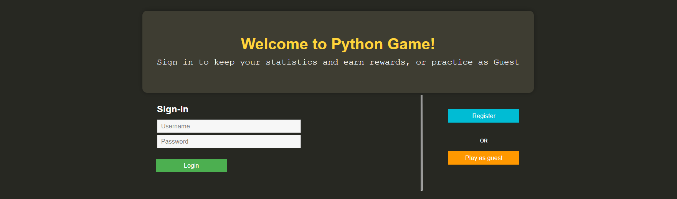

Possible mistakes: The user may encounter alerts when entering incorrect usernames or passwords, or if they forget to enter one/two of them.

* **Registration screen**  
  A "Register" button is available in the previous screen, which will direct him to this screen where he can enter a desired username, password, and confirm the password. After entering the required information, he can click on the "Submit" button to complete the registration process. Upon successful registration, he will be redirected to the home page screen. He can also go back to the previous screen by clicking on "Back" button.

Possible mistakes: If the user mistakenly confirms an incorrect password or enters an existing username, they will receive an alert indicating the error.

* **Home screen** (**not administrator users)**

Within the game interface, the user has several options available. They can initiate the game by clicking on the "Start Game" button, view the leaderboard to track their progress and compare scores, explore various classes of Python to enhance their knowledge, access helpful resources by clicking on the "Help" button, and finally, logout from the game when they wish to exit or switch accounts (will direct him to Welcome page).



* **Game screen**
  + **Game explanation screen**

When starting the game, the user is presented with an explanation screen and can proceed by clicking "Continue" or go back to the home page.

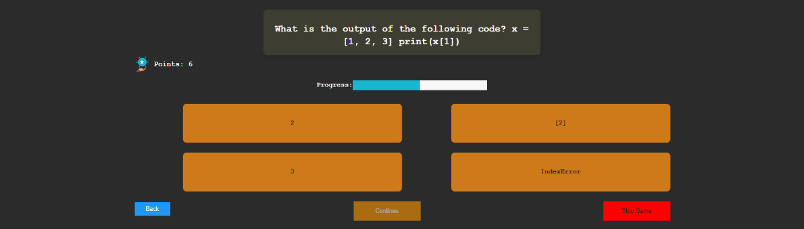Users select the right answer for each question. Getting it right on the first try earns 3 points, on the second try 2 points, on the third try 1 point. No points for the last available answer. Incorrect answers are red, correct answers are green. Users can see their points, go back or continue (will be enabled only after the user has selected one possible answer), or stop the game. Also displays user's points and a progress bar.

* **End game screen**

Once the user has finished answering all the questions or after clicking on "Stop Game" button, he will be directed to a summary screen. This screen displays the total points earned, the number of correct answers, the potential points that could have been earned, and the success rate. Additionally, the user is awarded a game budget based on the points achieved.

The summary screen also includes two graphs: one representing the game statistics (number of attempts) and another displaying the distribution of total attempts. To return to the home page, the user can simply click the green button located on the left side of the page.



* **Leaderboard screen**

The user has the option to view the leaderboard, which displays the top ten players. If the user is among the top ten, their name will be highlighted. Otherwise, their position in the leaderboard will be shown. The user can go back to home page screen.

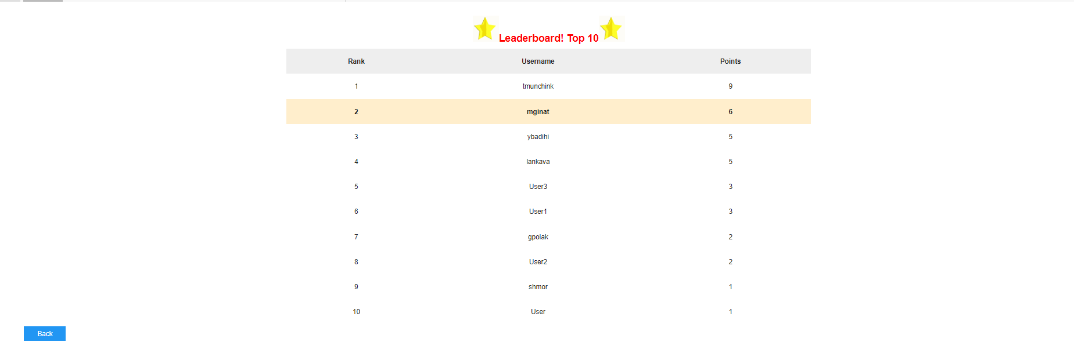

* **Classes screen**

Before starting the game, the user can access informative Python classes. They can watch an educational video by clicking on it to gain knowledge prior to playing. Additionally, the user has the option to easily navigate back to the home page if desired.

* **Help screen**

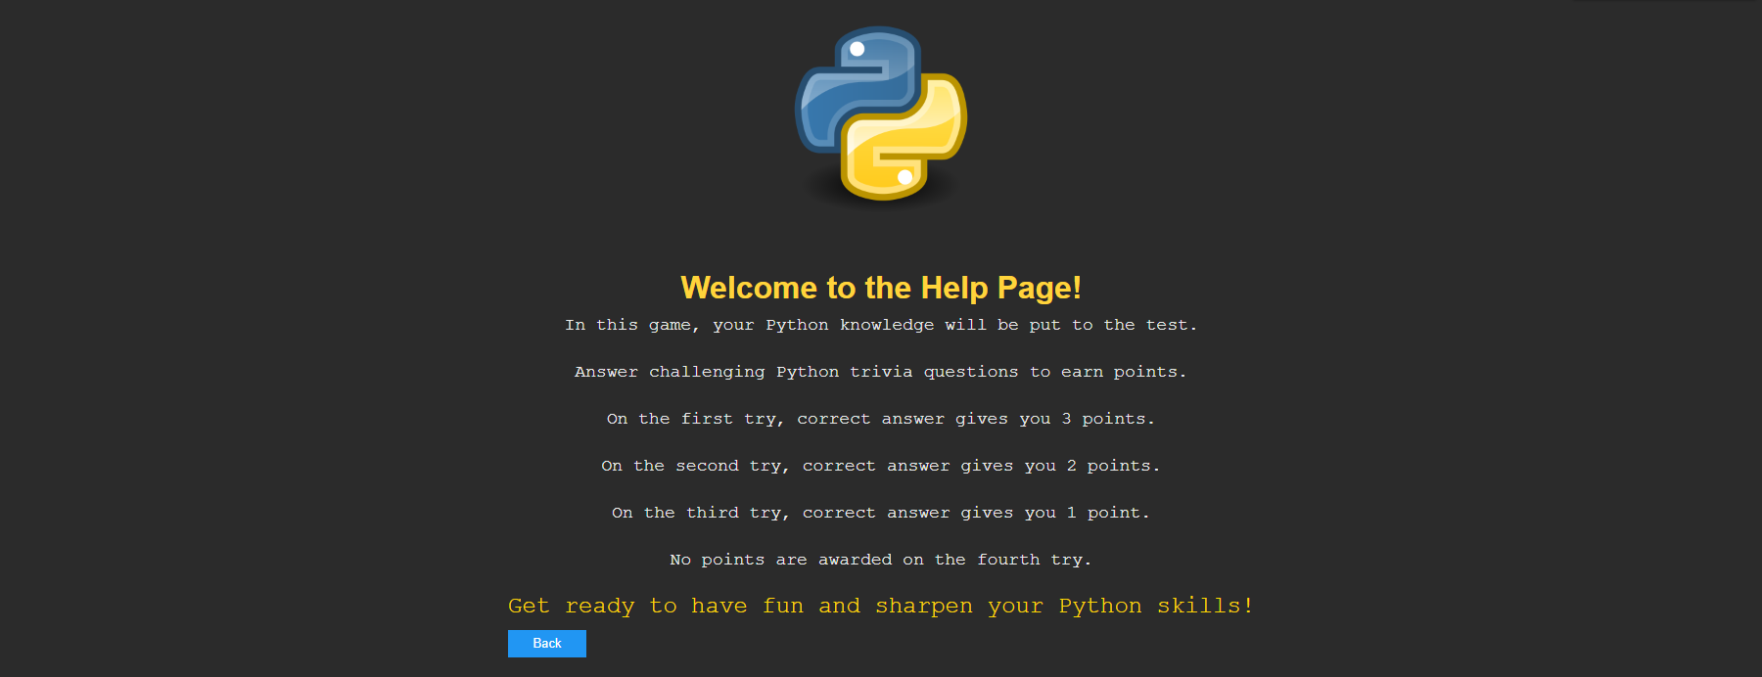On the home page screen, users have the option to click on the "Help" button before starting the game. This feature provides a description and explanation of the game, offering users valuable information to understand its mechanics and rules. Additionally, the user has the option to easily navigate back to the home page if desired.

* **Home screen** (**administrator users)**

For administrators, their home page is like regular users, but with the added functionality of two additional buttons: "Edit Questions" and "Add Questions". These buttons provide administrators the ability to modify existing questions or add new ones, ensuring the game remains dynamic and up to date with the latest content.



* **Edit questions**As an administrator, he has the option to edit questions by clicking on the "Questions" button. At any time, he can choose to go back to the home page.

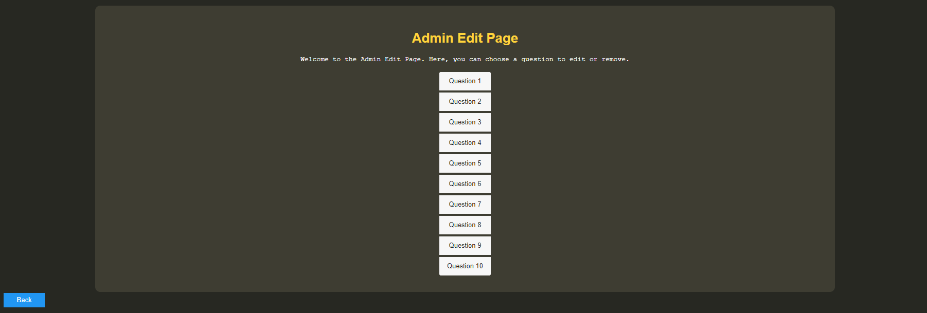

Once the desired question is selected, it will be taken the user to a screen where he can edit or remove the question by clicking on the corresponding buttons. The question will be displayed, with the correct answer highlighted in green. He has the flexibility to edit any other parts of the question by clicking on them. At any time, he can choose to go back to the home page.

If the user chooses to edit the question, the following screen will be presented to him. He can modify the question text, possible answers, and the correct answer by clicking on the respective combo-boxes. To save the changes, he can simply click on the "Save" button. If he wants to go back to the previous page, he has that option as well. Additionally, he can edit other questions by clicking on them. At any time, he can choose to go back to the home page by clicking the "Back" button at the left.

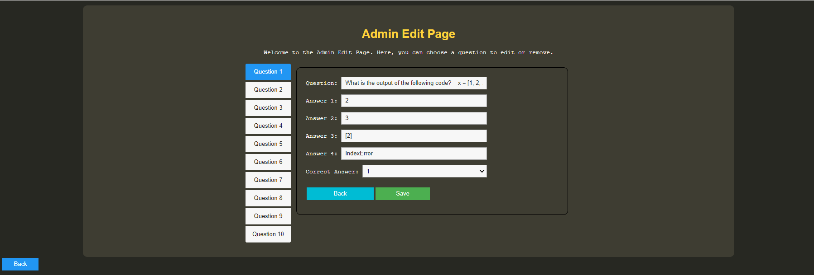

* **Add questions**  
  As an administrator, he has the privilege to add questions. In this screen, he can enter the question, along with the possible answers and the correct answer for that question. Once he has entered all the necessary information, simply click on the "Insert" button to add the question to the game.

